WESTERN NEW YORK REGIONAL
SHOWJUMPING RALLY
SUNDAY JUNE 9th 2019
Chestnut Ridge Equestrian Center, 7913 Chestnut Ridge Rd, Gasport NY 14067
Hosted By EAST AURORA PONY CLUB

**This is a Qualifying Rally under new 2019 rules for Championships (C1 and 12 yrs or older at Intro level 2’6’ and up) and Modified Championships (D2 competitors age 10 yrs & up- at Intro level 2’6”and up)**.
Please reference the new 2019 ShowJumping Rulebook and Newsletter for changes to age qualifications, attire, etc.
When/Where:
Sunday June 9th 2019
Grounds open at 6:30
Briefing at 7:30
Chestnut Ridge Equestrian Center, 7913 Chestnut Ridge Rd, Gasport NY 14067

Competition:
Teams of 3 or 4 riders, mixed divisions and ratings OK - D1 & up (Unrated allowed with DC approval)
Young D1 and/or UR riders must be on a D1/UR team and have a dedicated C advisor (older D1s/UR can be on mixed teams w DC approval)
All competitors except Ground Pole division will ride three rounds – one round will have an equitation score. One round will be “Take Your Own Line” (except Ground Pole Division)
Horsemasters will compete as regular competitors and will not be placed in separate division
Stable Manager is not required but is highly recommended
Individual Entries and/or incomplete teams welcome and will be assigned Scramble teams
One horse may be shared between two riders per team – Non Qualifying Divisions Only
Showjumping Rally baseball caps for all competitors, Stable Managers and C Advisors!

Trailers and Stabling:
Clubs will have assigned area. Trailers will be directed by parking attendant, plenty of room for trailer parking.
Stalls available for $30.00, initial bedding supplied. Stall stripping required after competition.

Horse Management / Kit Set Up to be done at Trailers – Trailer area is convenient to rings and competition. Water and manure disposal will be close to trailering and stabling areas.

NO DOGS PLEASE – Chestnut Ridge is a boarding facility.

Food: Competitors, Stable Managers and C advisors will be provided a lunch and ice cream token! Concession, Food Truck and Ice Cream on site.

Officials:
Technical Delegate: Lori Underwood
Chief Horse Management Judge: TBD
Horse Management Officials: Regional Team
Judges: Troy Wing, 2nd Judge TBD
Veterinarian: TBD
Ferrier: TBD
EMT: TBD

Lodging:
Hotels located along Transit Road in Lockport NY, 12-15 minute drive from competition. Rooms starting at $79 per night:
Best Western Plus – Lockport NY
Quality Inn – Lockport NY
Hampton Inn – Lockport NY

Paperwork:
Please email / txt your approximate attendance / team headcount as soon as possible to:
Lynda Maywalt EAPC DC lmaywalt@yahoo.com
Questions to Lynda – email or txt/call 716-912-9427

Entries postmarked by MONDAY May 20th to:
Lynda Maywalt
5500 Reiter Road
East Aurora, NY 14052

Checklist:
- Team & Individual Entry Form – 1 per team
- Coggins (2018 or 2019) and Rabies Form dated within 1 year – 1 per mount
- Chaperone Form – 1 per team
- Coaches Form – if coach will be present – teams can share coaches
- Volunteer Names Listed
- Release of Liability Form for facility – Chestnut Ridge Equestrian Center
- Emergency Contact Form for competitors 18 years of age or older without Chaperone
- Check Payable To: EAPC
Entry Fees - $65 per competitor, Stable Manager $10
Stabling Fees - $30 per stall

WESTERN NEW YORK REGIONAL SHOWJUMPING RALLY
SUNDAY JUNE 9th 2019
DIVISIONS:
Ground Poles – Non Qualifying Intro. 2'6” - Qualifying
18” – Non Qualifying Developing Horse & Rider 2'9”-3’ - Qualifying
Mini - 2 Foot – Non Qualifying Horse 1 - 3’- 3’3”- Qualifying
TEAM & INDIVIDUAL ENTRY FORM
# | COMPETITOR NAME –  CONTACT EMAIL & PHONE | RATING | AGE  as of 1/1/19 | DIVISION | MOUNT-  Name-Age-Gender-Breed | MARK C -Captain, SM - Stable Manager | Qualifying?  Y or N

TEAM NAME: _______________________________________________________

# OF STALLS REQUIRED IF STABLING ($30 per stall include with entry): _____________

CHAPERONE & PHONE: _______________________________________________

COACH & PHONE: ___________________________________________________

C–ADVISOR: ______________________________________________

VOLUNTEER NAME & PHONE __________________________________________

VOLUNTEER NAME & PHONE: __________________________________________

DC SIGNATURE & DATE: _______________________________________________

ONLY For Competitors Over 18 attending without Chaperone:

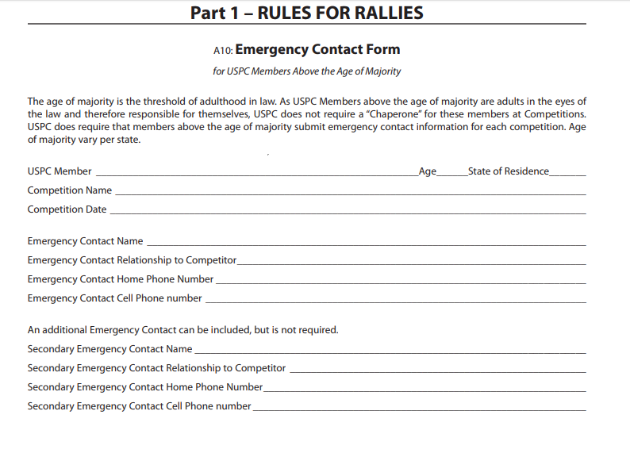

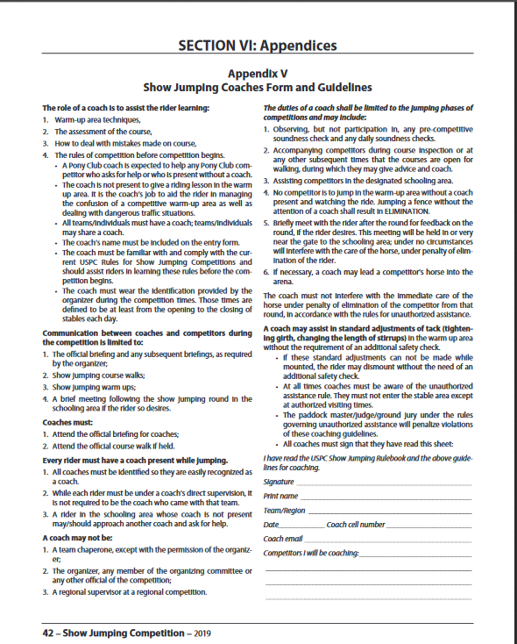

RELEASE OF LIABILITY: PLEASE READ BEFORE SIGNING.

The undersigned competitor and any signing parent/guardian or
owner hereby agrees to release the management of this competition, their officers, directors, employees, members or agents , representatives and managers of the grounds of Chestnut Ridge of any loss, damage, liability or injury arising out of or resulting from
this competition or competitors participation or entry therein, including negligent acts or omissions of the management of the
competition of their officers, directors, employees, or agents, representatives and managers of the grounds of Chestnut Ridge.

CHESTNUT RIDGE EQUESTRIAN CENTER
7913 Chestnut Ridge Road
GASPORT, NY 14067
www.chestnutridgeequestriancenter.com

RIDER SIGNATURE OR PARENT/GUARDIAN IF UNDER 18 YRS

SIGNED______________________________________DATE__________

